Managing and Adapting Practice (MAP):
Evidence-Based Practices in OMH-Licensed Community Based Provider Agencies to Serve Children with Significant Mental Health Needs and their Families

Attestation
MAP Funding Requirements:
Staff attending MAP training must:
- Commit to the training program for 4-5 months
- Provide direct clinical services
- Carry a caseload that includes at least 3 children or adolescents
- Frequently treat childhood anxiety, depression, trauma, and/or disruptive behavior disorder
OR supervise clinicians who meet the above criteria (These clinicians must also be participating in MAP training)

Full commitment to the MAP training includes:
- Participation in a 1-hour pre-training webinar and 4 days of webinar-based training
- Participation in at least 6 of 8 webinar consultations (bi-weekly by video conference) across 4 months
- Participation in a 4-hour mid-point webinar training (held 2 months after the initial 4-day training)
- Submission of certification materials at the end of the 5-month period with a passing score to qualify for certification
- All three individuals’ complete trainings and receive receipt of NYS MAP certification
- Integration and continued use of MAP for a minimum of 6 months post certification
- All three individuals participate in training feedback and attendance at no more than 2 one-hour sessions with OMH regarding the promotion and applications of MAP more widely in NYS
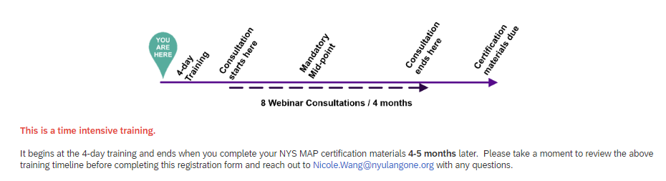

I attest to understanding and agree to all the required components of participation:

Name: __________________________________________________________________________

Signature: _____________ Date: ________________________

Agency: ______________________ ____________________________________________________

